Project Design Phase-II
Technology Stack (Architecture & Stack)

Date | 05 July 2026
Team ID | Solo Project – Individual Capstone
Project Name | Library Management System (ServiceNow)
Maximum Marks | 4 Marks

Technical Architecture:
The Deliverable shall include the architectural diagram as below and the information as per the table1 & table 2
Example: Order processing during pandemics for offline mode
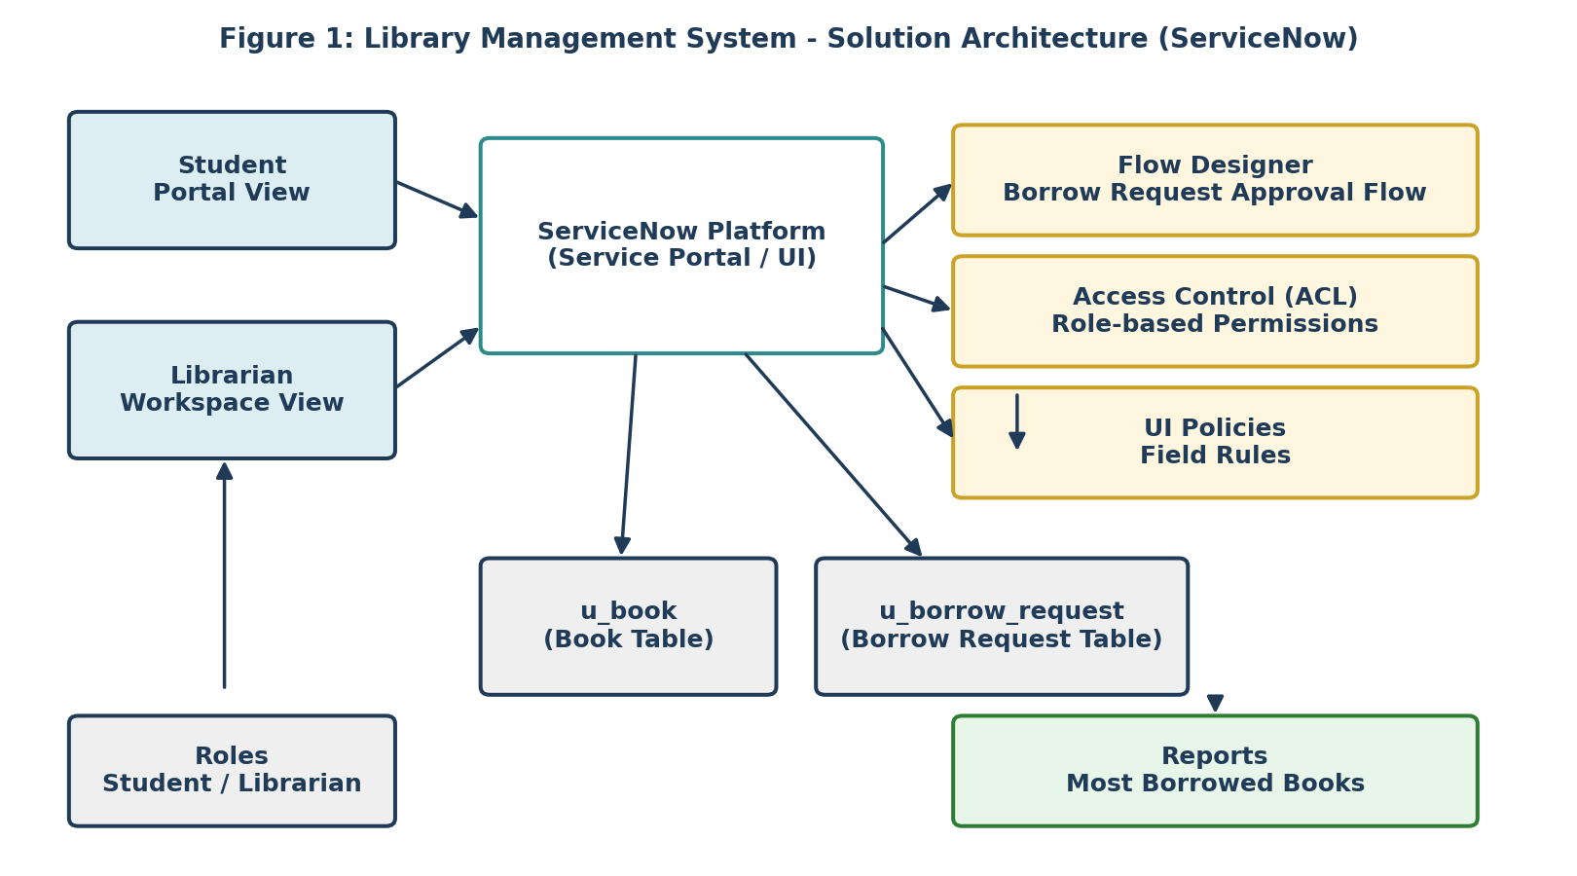
Reference: https://developer.ibm.com/patterns/ai-powered-backend-system-for-order-processing-during-pandemics/
Table-1 : Components & Technologies:
S.No | Component | Description | Technology
1. | User Interface | How students & librarians interact with the application | ServiceNow Service Portal / native platform UI forms
2. | Application Logic-1 | Approval and status-update logic for borrow requests | Flow Designer (Borrow Request Approval Flow)
3. | Application Logic-2 | Field-level usability rules (mandatory Return Date on Issue) | UI Policies
4. | Application Logic-3 | Restricts book selection to available copies only | Reference Qualifier (Simple, on Book reference field)
5. | Database | Stores catalog and transaction data | ServiceNow native tables (u_book, u_borrow_request)
6. | Cloud Database | Platform-managed backend data store | ServiceNow-hosted database (Personal Developer Instance)
7. | File Storage | Not required for current release (no attachments) | Not applicable
8. | External API-1 | Not used in current scope | Not applicable
9. | External API-2 | Not applicable in current scope | Not applicable
10. | Machine Learning Model | Not applicable in current scope | Not applicable
11. | Infrastructure (Server / Cloud) | Application deployed and tested on a ServiceNow Personal Developer Instance (PDI).  Local Server Configuration: Not applicable (cloud-hosted PDI)  Cloud Server Configuration: ServiceNow-managed multi-instance cloud | ServiceNow PDI (Cloud)

Table-2: Application Characteristics:
S. No | Characteristics | Description | Technology
1. | Open-Source Frameworks | None — built entirely on ServiceNow's proprietary low-code Now Platform | Now Platform (Flow Designer, Service Portal, GlideRecord)
2. | Security Implementations | Role-based Access Control Lists (ACLs) restrict Create/Read/Write/Delete per role; Reference Qualifier prevents invalid data entry | ServiceNow ACL engine, role-based security
3. | Scalable Architecture | Modular custom-table design (u_book, u_borrow_request) allows new related services to be added without re-architecture | ServiceNow table extension model
4. | Availability | Hosted on ServiceNow's cloud infrastructure with platform-managed uptime/SLA | ServiceNow multi-instance cloud
5. | Performance | Reference Qualifier limits records returned to forms; reports pre-aggregate data via Group By/Count | ServiceNow Reporting engine, optimized GlideRecord queries

